Homework: (6 points)  
請至今日 ceiba 課程區下載 rates.sas, Poisson regression 實例：標準化死亡率 (以每十萬人年為單位) 是否與性別 (以女生作為基準組) 或年齡層 (以 5 作為基準組) 有關？  
(1) Please write down the statistical model.

log(deaths) = log(spy) + β0 + β1male + β2year1 + β3year2 + β4year3 + β5year4 + β6year6 + β7year7 + β8year8 + β9year9 + β10year10 + β11year11 + β12year12

deaths為死亡人數，spy 為每十萬人年

code:

**proc** **genmod** data=d1;

class sex (ref="f") year (ref="5") / param=ref;

model deaths = sex year / dist = poisson link = log offset = o;

**run**;

sex 與 year 為類別變數，分別以女性和第五個年齡層作為reference

(2) According to the deviance statistic, is the model fitted well? (given significance level = 0.05).

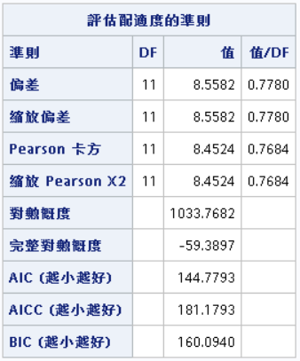

Deviance=8.5582

H0:本model與saturated model無異

H1:本model與saturated model有差異

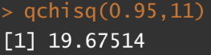

透過卡方檢定自由度為11, 8.5582<19.67514,無法拒絕虛無假說,此model與saturated model無異,配適不錯。

(3) Please explain the regression coefficients that are statistically significant (given significance level = 0.01).

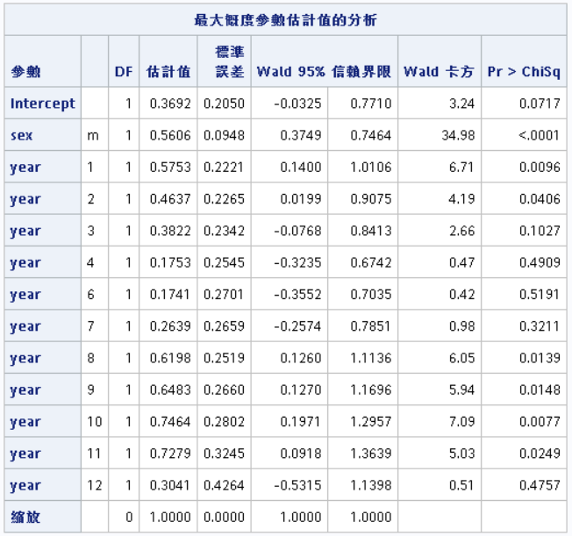

由上表可知 sex、year1、year10 顯著(P-value <0.01)

因此可解釋為：

1. 假設其他條件不變，男生的標準死亡率為女性的exp(0.5606) = 1.7517倍

2. 假設其他條件不變，30-34 歲年齡層的標準死亡率為 50-54 歲的exp(0.5753) = 1.777倍

3. 假設其他條件不變，75-79 歲年齡層的標準死亡率為 50-54 歲的exp(0.7464) = 2.1094倍